Civil war in Sierra Leone

UNSC Resolution: | 1334
Date of adoption: | 22 December 2000
Operative paragraph: | 2
Demand number: | 1

Megan MacKenzie

Wording of demand

give a more convincing demonstration of commitment to the peace process

List of addressees of the demand
Revolutionary United Front

Short-term compliance

Description of the addressee(s)’ conduct
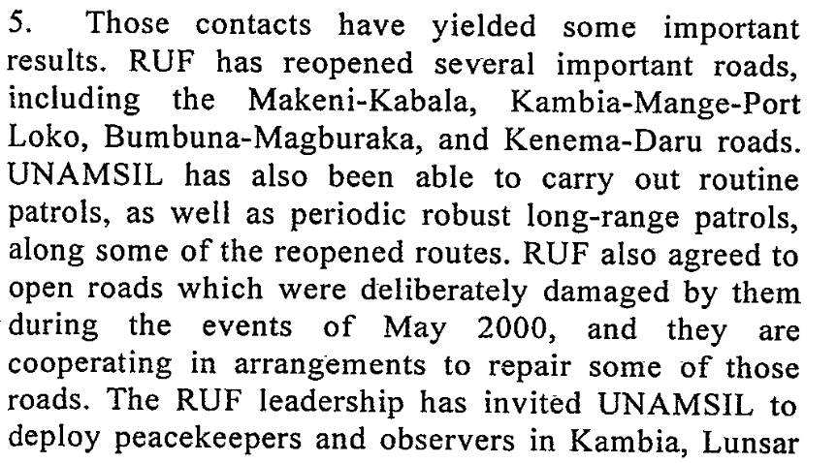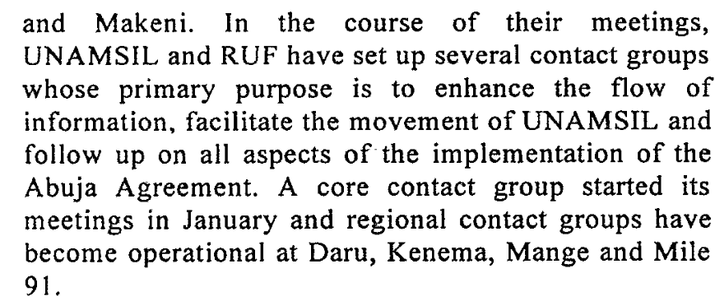
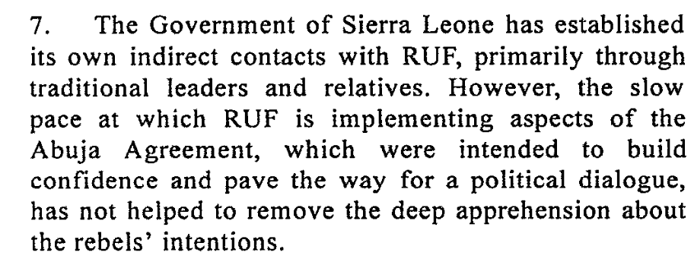14 March 2001

Assessment

Short-term compliance
No or marginal compliance (1) | x Medium low compliance (2) | Medium high compliance (3) | Full or almost full compliance (4)

Considerations underlying the assessment
The RUF showed some signs of complying with this demand. They changed some of their behaviors and were involved in talks with the Government of Sierra Leone.

Medium-term compliance

Description of the addressee(s)’ conduct
2. The Sierra Leone peace process continued to make encouraging progress during the period under review. The disarmament of combatants of the Revolutionary United Front (RUF) and the Civil Defence Forces (CDF) has so far been completed in four districts, including the diamond-producing Kono district. With the exception of skirmishes between the Civil Defence Forces and RUF which marred the initial stages of the disarmament exercise in Kono district, the ceasefire has generally continued to hold.
3. The joint committee on disarmament, demobilization and reintegration comprising
UNAMSIL, the Government of Sierra Leone and RUF held two meetings during the reporting period, the first in Bo on 17 July and the second in Kenema on 10 August.
4. At the meeting held in the town of Bo on 17 July, RUF requested the Government to facilitate its registration as a political party and to release some of the RUF officials detained during the crisis of May 2000.
6. The Government and RUF have also taken additional reciprocal confidence-building measures,including the continuing release of abductees and child combatants by RUF, the participation by both sides in joint sensitization and reconciliation campaigns, the
enrolment of some RUF ex-combatants in the military reintegration programme, the renewal of the provisional registration of the RUF Party by the National Electoral Commission and an invitation to the party to participate in discussions on the electoral process. 7 September 2001

Assessment

Medium-term compliance
No or marginal compliance (1) | Medium low compliance (2) | x Medium high compliance (3) | Full or almost full compliance (4)

Considerations underlying the assessment
Although this period was still characterized by violence and human rights abuses, the resolution asks for a more convincing demonstration of commitment to the peace process. As such, there are several indicators that the RUF were committed to the peace process and were changing their behaviors.

Depth of demand

Assessment

Level of depth of demand
Low depth of demand (1) | x Medium depth of demand (2) | High depth of demand (3)

Considerations underlying the assessment

This is a medium depth demand because it does asks the party to show commitment to the peace process but does not give specific indications of what actions the party should take or what time frame the party should act within. As such, even though the party continued to precipitate violence and human rights abuses, they also showed some commitment to the peace process.

Level of confidence about coding decisions

Level of confidence about coding decision
Extremely high | x High | Moderate

Comments to IPI (if any)

Eleventh Report of the Secretary-General on UNAMSIL, (S/2001/857), 07/09/2001.

